  REPBULIC OF RWANDA MINISTRY OF HEALTH  …………. PROVINCE  …………. DISTRICT  …………. HOSPITAL  P.O Box ……………..  Email: ……………… | Policy/Procedure Title: Smoking
 | Policy Code/ Number:  LM1-02 | Effective Date:  August 2018 | Revision Date:  July 2020
 | Department:  Cross-cutting | Applies To: All staff and visitors

 | Position | Names | Date & Signature
Responsible | Environmental Health Officer
Supervisor | Director of Medical and Allied Health Sciences Services
Approval | Director General

Purpose: To foster a healthy environment for all staff, patients, and public within the hospital from the effects of smoking on the hospital premise, including preventing a potential fire incident.

Policy statements:
- The hospital shall ensure that smoking at the hospital is prohibited.
- The hospital shall ensure that no smoking signage is displayed throughout the hospital premise.

Definitions:
- Smoking: The action or habit of inhaling and exhaling the smoke of tobacco or a drug.

Equipment/forms:
- NO SMOKING signs

Procedures:
- Hospital leadership avail signage to prohibit smoking.
- Health and Safety Committee identifies adequate areas to post the “NO SMOKING” signs.
- Environmental Health Officer displays the “NO SMOKING” signs in identified places, including entrances.
- Environmental Health Officer ensure that all ambulances have “NO SMOKING” signage.
- All hospital staff shall inform patients and visitors of the no smoking policy.
- All staff members should report non-compliance of this policy to the Environmental Health Officer.
- The Environmental Health Officer organizes a mechanism to monitor compliance of No Smoking policy, aggregates data reported, and takes action for improvement.

References:
- University of Bristol (2015), Smoking policy, Version 5
- Smokefree and Tobaccofree US and Tribal Colleges and Universities, American Nonsmokers’ rights foundation, Carfornia, April 2013
- Davorka Gazdek (2013), Croatian smoke-free law and smoking habits among employees of health care facilities in Koprivnica-Križevci County, Department of Public Health and Social Medicine, Public Health Institute of Koprivnica-Križevci County, Koprivnica, Croatia
- The Joint Commission (2011), Keeping Your Hospital Property Smoke-Free: Successful Strategies for Effective Policy Enforcement and Maintenance, Henry Ford Health System.
- District hospital operational policies & procedures, patient centered care services, September 2012.
- www.google.rw/search?q=non+smoking&rlz=1C2EODB_enRW566RW566&tbm=isch&source=iu&imgil
Appendix: Sign of “No Smoking”

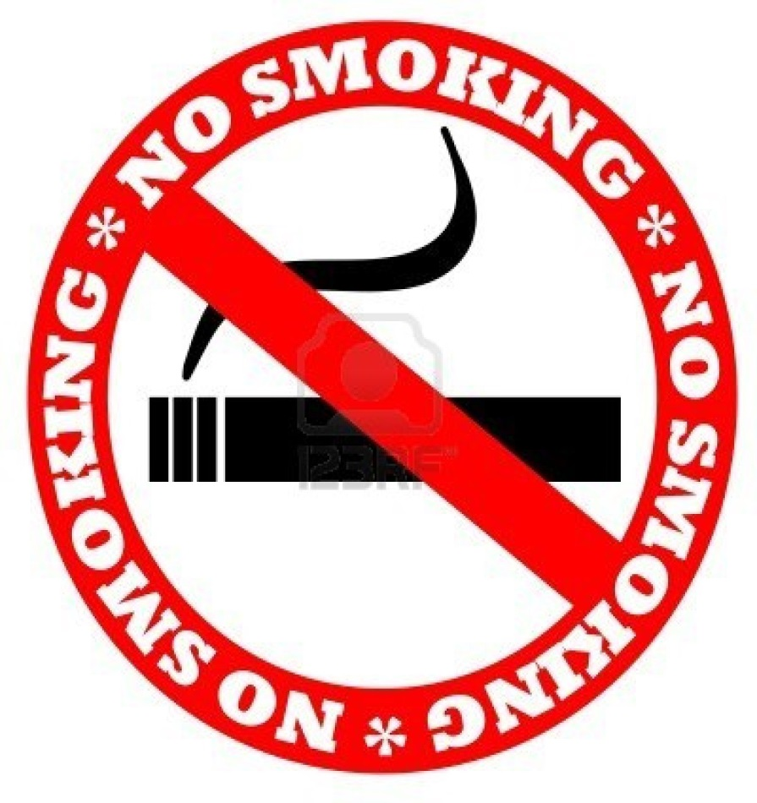

NO SMOKING / BIRABUJIJWE KUNYWERA ITABI MUBITARO / IL EST STRICTEMENT INTEDIT DE FUMER A L’HOPITAL

