  REPUBLIC OF RWANDA  MINISTRY OF HEALTH  …………. PROVINCE  …………. DISTRICT  …………. HOSPITAL  P.O Box ……………..  Email: ……………… | Policy/Procedure Title: Hand Hygiene
 | Policy code/ Number: ES3-04 | Effective Date:  August 2018 | Revision date:  July 2020
 | Department: Cross cutting | Applies to: All staff, patients, and visitors

 | Position | Names | Date& Signature
Responsible | Environmental Health Officer
Supervisor | Director of Medical and Allied Health Sciences Services
Approval | Director General

Purpose: To avoid the transmission of harmful germs and to prevent health care associated infections through appropriate hand hygiene.

Policy Statements:
- Hospital shall enforce appropriate hand hygiene to minimize the cross-contamination of healthcare associated infections.

Definitions:
- Hand washing: the act of cleansing the hands with water or other liquid with soap or another detergent for the purpose of removing soil or microorganisms.
- Hand disinfection: through hand cleansing (using antibacterial detergent and running water followed by application of an alcoholic disinfectant preparation) to reduce resident flora and remove all traces of patient or fomite contact.
- Surgical hand washing: a procedure of cleaning hands performed before and after any surgical intervention.
Equipment/Forms:
- Hand hygiene facilities (water source, soap, alcohol, driers,…)
- Poster for hand hygiene
Procedures:

Hand washing
- Environmental Health Officer avails sufficient hand hygiene materials.
- Staff and visitors shall comply with hand washing guidelines:
  - Push long sleeves above elbows.
  - Remove jewelry on hand and wrist e.g. rings, watches, and bracelets.
  - Inspect hand surfaces for cuts/abrasions.
  - Turn on tap and, using cold or lukewarm water, wet hands and wrists thoroughly under running water.
  - Keep hands and forearms lower than elbows during washing.
  - Apply sufficient soap to lather all surfaces of hands, fingers, and wrists.
  - Rub hands together vigorously for a minimum of 20 seconds.
  - Pay particular attention to areas under nails, on the back of the hands, and between fingers and thumbs.
  - Rinse well under clean running water until all traces of soap are removed.
  - Dry thoroughly from tip of fingers to wrist with paper towel.
  - Discard paper towel into a proper receptacle.
  - Use a dry paper towel to turn off tap if tap is not elbow-controlled.

Hand disinfection
- Environmental Health Officer avails sufficient hand hygiene materials.
- Staff and visitors shall comply with hand disinfection guidelines:
  - Ensure your hands are not visibly dirty otherwise refer to Hand Washing Policy and its guidelines.
  - Push long sleeves above elbows.
  - Remove jewelry on hand and wrist e.g. rings, watches, and bracelets.
  - Apply recommended hand disinfection agents to all surfaces of hands, fingers, and wrists, sufficient to dry hands, a minimum of 20 seconds.
  - Rub hands together vigorously, covering all surfaces until dry.

Surgical hand scrub
- Environmental Health Officer avails sufficient hand hygiene materials.
- Staff and visitors shall comply with surgical hand scrub guidelines:
  - Apply masks covering nose and mouth.
  - Remove all jewelry from hands and arms.
  - Tuck all hair, ears, neck, and jewelry into scrub cup/scrub clothes.
  - Turn on tap and, using cold or lukewarm water, wet hands and arms up to above the elbow under clean running water, always holding hands with fingers up in a vertical position.
  - Apply hospital-approved antiseptic soap liberally and lather all surfaces from fingertips to 5 centimeters above the elbow.
  - Using a circular motion and beginning at the nails one by one and fingertips of one hand, lather and wash all surfaces, including tips of fingers, between fingers, sides of hands, palm and back of hand, continuing from fingertips to below the elbow.
  - Repeat procedure for the other hand and arm.
  - Keep hands and uniform away from taps and sink surfaces throughout the procedure. Begin the procedure again if these surfaces are touched at any time.
  - Rinse each arm separately, fingertips first, holding hands above the level of the elbow.
  - Dry one hand thoroughly in fingers-up position using the sterile towel. Wipe from the fingertips to the elbow.
  - Dry the other hand by carefully reversing the towel or using a new sterile towel.
  - Discard towel in appropriate container.

Hand Hygiene Monitoring

- Environmental Health Officer shall monitor compliance with hand hygiene guidelines
  - Environmental Health Officer conducts facility tour and observes hand hygiene compliance daily.
  - Environmental Health Officer shall avail a monthly report detailing the compliance with hand hygiene guidelines.
  - Environmental Health Officer shall develop an improvement plan and submit to IPC Committee.
  - IPC Committee submits the plan to the Hospital Management Committee for approval and appropriate action.

References:
- www.who.int/.../Hand_Hygiene_Why_How_and_When_Brochure
- WHO Guidelines on Hand Hygiene in Health Care (2009) First Global Patient Safety
- Challenge Clean Care is Safer Care. World Health Organization. Geneva.

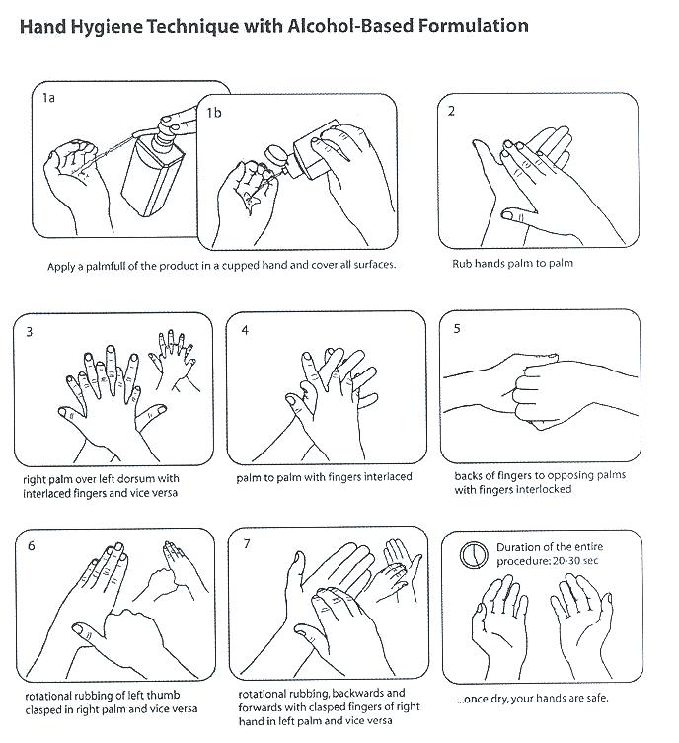
Appendix 1:

Appendix II: 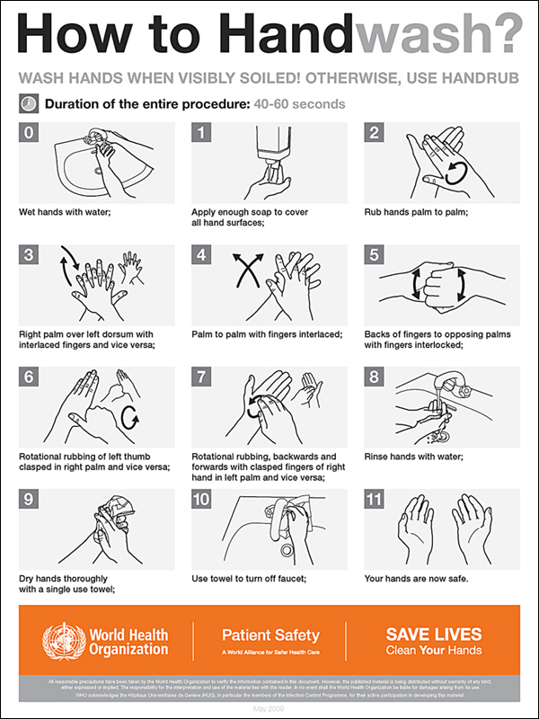

Appendix III: 5 Moments for hand hygiene
